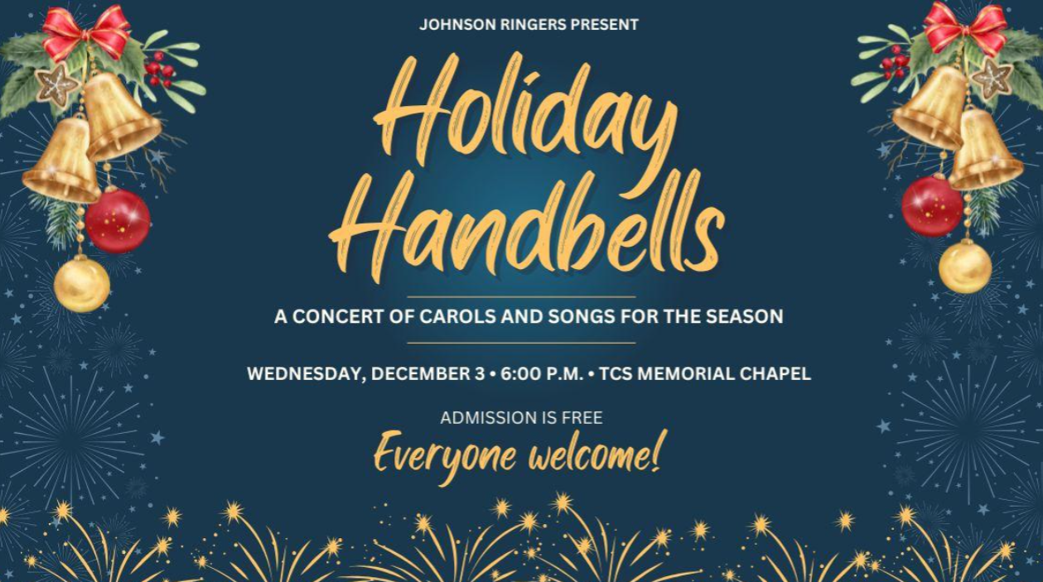
Wednesday, December 3
6pm-6:45pm
The Memorial Chapel
Trinity College School
140 Ward St., Port Hope
Part of Week Without Walls at TCS

